Cache Controller

1.FSM DESIGN
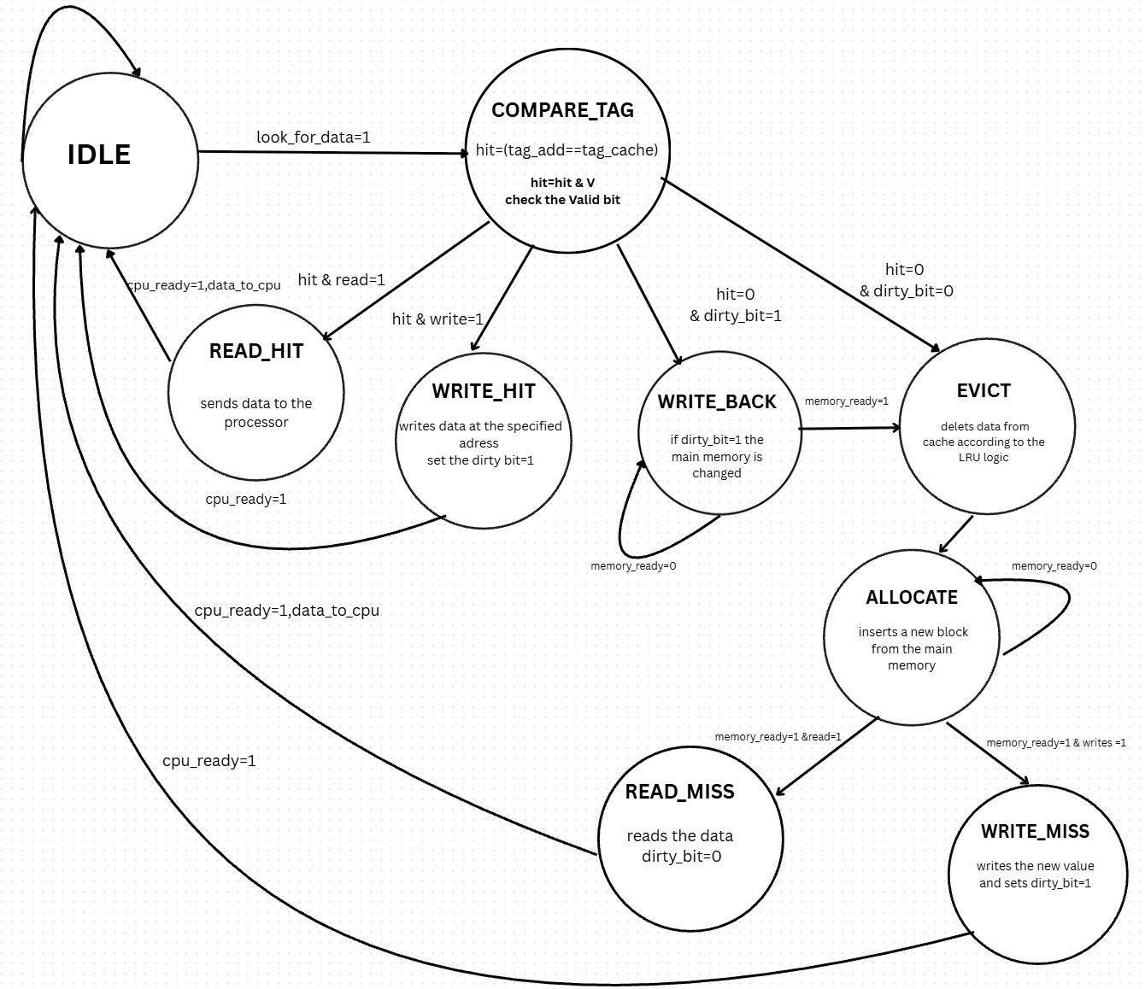

1.1Description of the States

IDLE
-This state waits for a valid read or write request from the processor.
-If the processor sends a valid request, the finite state machine, FSM, moves to the COMPARE_TAG state.

COMPARE_TAG
-In this state, the Tag field from the address provided by the processor is compared with the tags already stored in the cache memory.
-If the address is found in the cache and the cache line is valid, then we have a cache hit. Depending on the operation requested by the processor, the FSM moves to either READ_HIT or WRITE_HIT.
-If the address is not found or the cache line is not valid, then we have a cache miss. In this case, the FSM moves to WRITE_BACK or EVICT, depending on the value of the dirty_bit.

READ_HIT
In this state, the requested address is already in the cache and it is valid.
The controller sends cpu_ready = 1 to the processor, together with the word stored at that address. This word is placed on the bus and sent back to the processor.
The exact word from the cache line is selected using the WO field, which means Word Offset.
The age of the cache line is also updated, because the cache uses the LRU policy, which means Least Recently Used. The accessed line gets age 0, because it was used most recently, and the age of the other lines is incremented.

WRITE_HIT
In this state, the requested address is found in the cache and the line is valid.
The word received from the processor is written into the cache line, at the position indicated by the WO field, meaning Word Offset.
After the write operation, the dirty_bit is set to 1. This means that the data in the cache was modified and is now different from the data in main memory.
At the end, the controller sends cpu_ready = 1, and the FSM returns to the IDLE state.
The age of the accessed line becomes 0, because it is now the most recently used line.

WRITE_BACK
The FSM enters this state when the selected cache line has dirty_bit = 1.
This means that the processor has written something into the cache, but the modified information has not yet been written to main memory. Because of this, the line cannot simply be deleted, because the modified data would be lost.
In this state, the controller takes the entire block from the cache and writes it back to main memory, RAM.
Using the Tag and Index fields, the controller knows where the modified data must be written in main memory.
The FSM stays in this state until the main memory finishes the operation and sends memory_ready = 1. This is needed because main memory is slower than cache memory, so the operation can take several clock cycles.
After the write-back operation is finished, the line is no longer considered dirty.

EVICT
This state is used to remove an old data block from the cache, in order to make space for a new block.
The controller reaches this state when the line that must be replaced has dirty_bit = 0. This means that the data in the cache is already the same as the data in main memory, so the block can be removed safely without losing modified data.
After the old block is removed, the FSM moves to the ALLOCATE state.

ALLOCATE
This is the state where the controller loads a new data block from main memory into the cache line that has just been freed.
Here, the controller also waits for the memory_ready signal, so it knows when the allocation process is finished.
After the new block is loaded into the cache, the age of that line becomes 0, because it is now the most recently used line.
READ_MISS
This state is similar to READ_HIT, but it happens only after a cache miss has been handled.
First, the needed block is brought from main memory into the cache. After that, the controller extracts the requested word from the cache line using the WO field, meaning Word Offset.
At the end, the controller sends cpu_ready = 1 and sends the extracted word back to the processor.
After the operation is finished, the FSM returns to the IDLE state.
The age of the accessed line remains 0, and the age of the other lines is incremented.

WRITE MISS
In this state, the controller takes the word sent by the processor and writes it into the cache line that has just been allocated.
The exact position inside the cache line is selected using the WO field, meaning Word Offset.
After the write operation, the dirty_bit is set to 1, because the data that was brought from main memory has now been modified in the cache.
At the end, the controller sends cpu_ready = 1, and the FSM returns to the IDLE state.
The age of the accessed line becomes 0, and the age of the other lines is incremented.

1.2 Inputs and outputs
1.2.1 INPUTS
NAME | FROM | DESCRIPTION
clock | System | Clock signal
rst | System | Reset signal
address | CPU | Address requested by the CPU
look_for_data | CPU | Signal indicating a valid read/write request
data_from_CPU | CPU | Data sent by CPU on write operations
WRITE/READ | CPU | Indicates whether the operation is a write or a read
memory_ready | RAM | Signal from main memory indicating operation is complete

1.2.2 OUTPUTS

NAME | TO | DESCRIPTION
cpu_ready | CPU | Signals the processor that the operation is complete
data_to_CPU | CPU | Data sent back to the processor on read operations
2.Verilog Implementation
The fsm module is a cache controller implemented as a finite state machine. It controls read/write operations and handles hit, miss, dirty bit, write-back, eviction, and allocation cases.
1. State Definitions
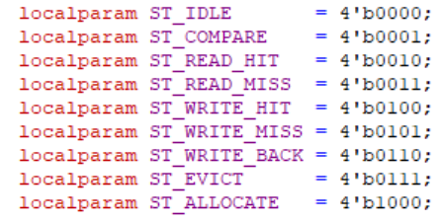
This section defines the states of the finite state machine. Each state represents a step in the cache operation, such as waiting, comparing, reading, writing, evicting, or allocating.
2. Internal Registers and Cache Memory
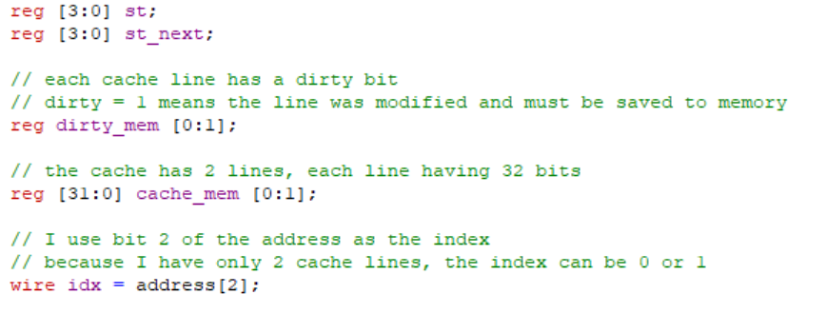
- st stores the current state
- st_next stores the next state
- cache_mem simulates two cache lines
- dirty_mem stores the dirty bit for each line
- idx selects the active cache line.

3. State and Dirty Bit Update
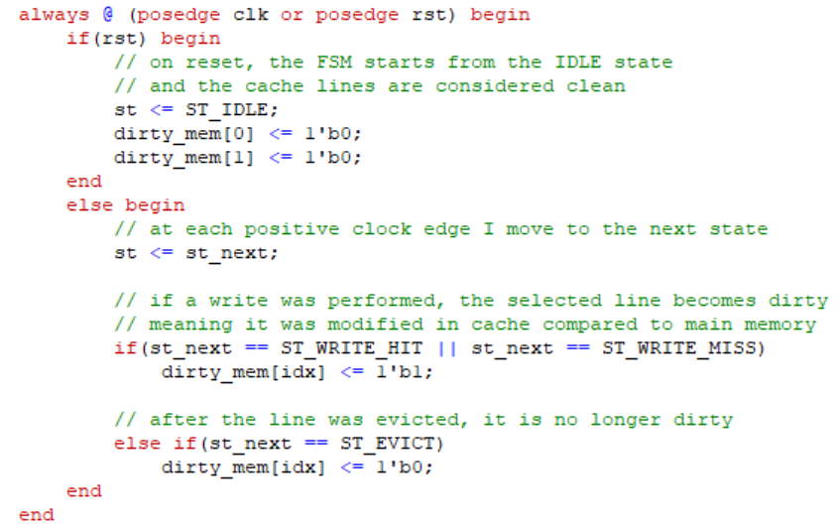
On reset, the FSM returns to IDLE, and both cache lines are marked clean. On each clock edge, the state is updated. A write operation sets the dirty bit, while eviction clears it.
4. Transition Logic
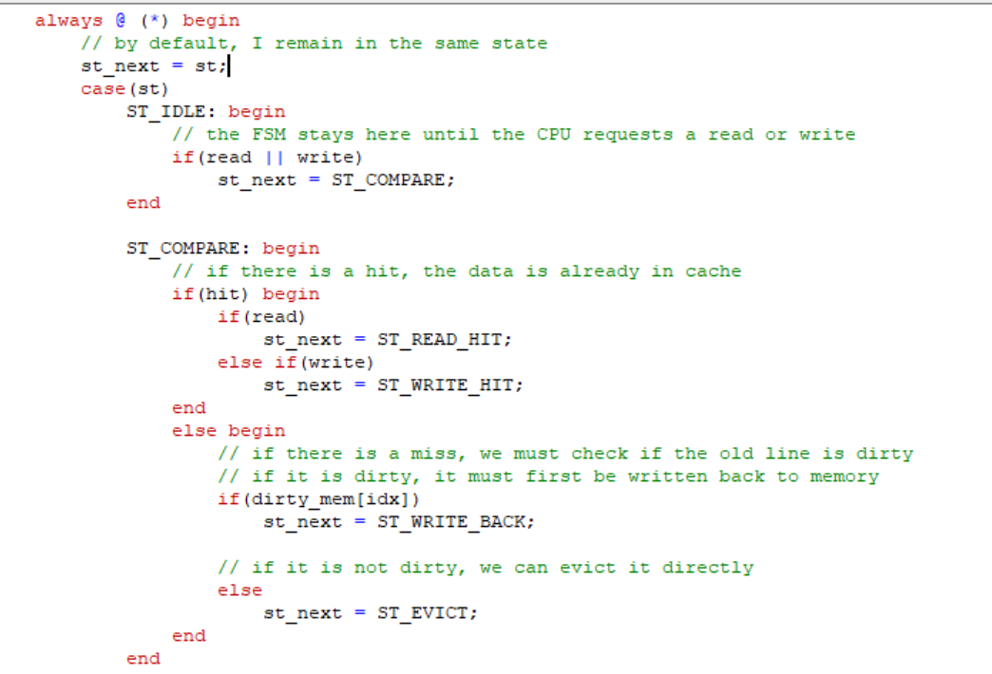

This block controls the state transitions. If there is a hit, the operation is done directly in cache. If there is a miss, the dirty bit is checked. A dirty line requires write-back before eviction and allocation.
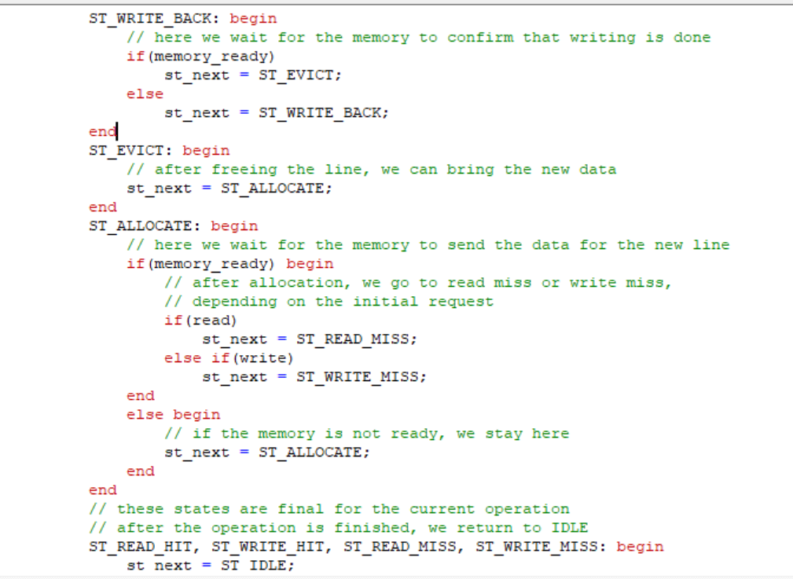
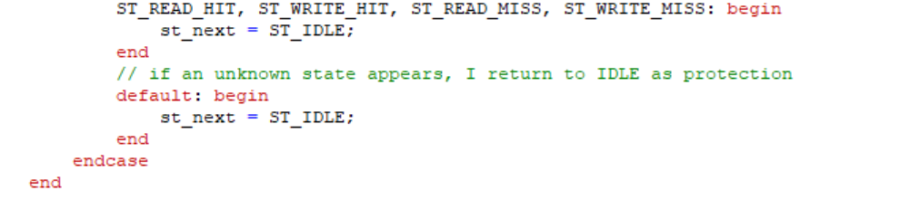
5. Cache Memory Update
This block updates the cache content. During a write operation, data from the CPU is stored in the selected cache line. During allocation, a new cache line is simulated as being loaded from memory.
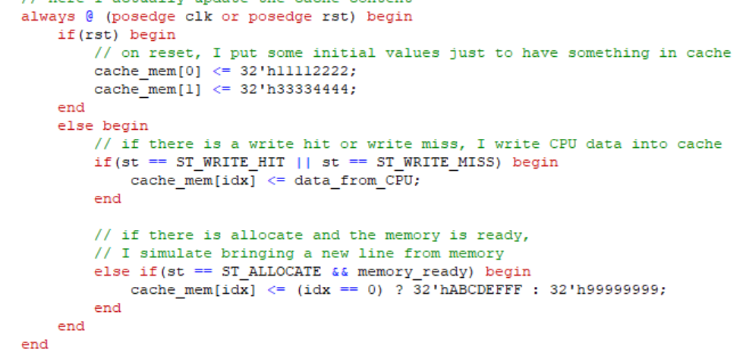

6. Output Logic
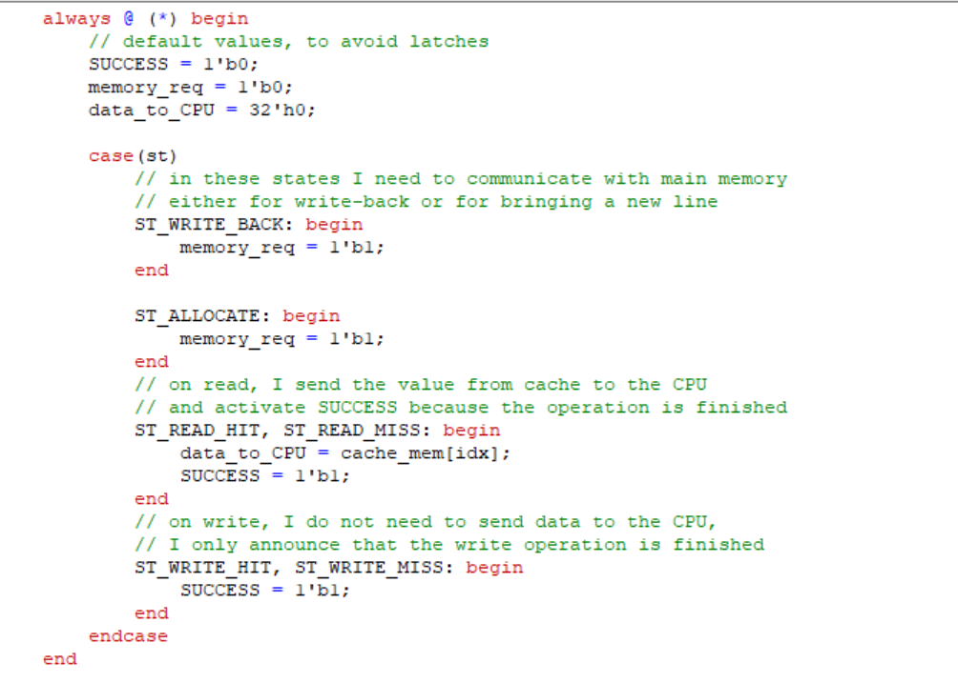
This block generates the output signals. memory_req is activated when main memory is needed. For read operations, data is sent to the CPU and SUCCESS is set. For write operations, only SUCCESS is set.

3.TESTBENCH & RESULTS

The fsm_tb module represents a Verilog testbench used to simulate and verify the behavior of the fsm module. The tested module implements the logic of a cache controller based on a finite state machine.
The purpose of this testbench is to generate different input scenarios, such as read operations, write operations, cache hits, cache misses, write-back situations, and memory allocation. By applying these test cases, the correct transitions between states and the correct output signals of the FSM can be observed.
1. Unit Under Test
Inside the testbench, the fsm module is instantiated as uut, which stands for Unit Under Test. This means that the FSM module is the circuit being tested.

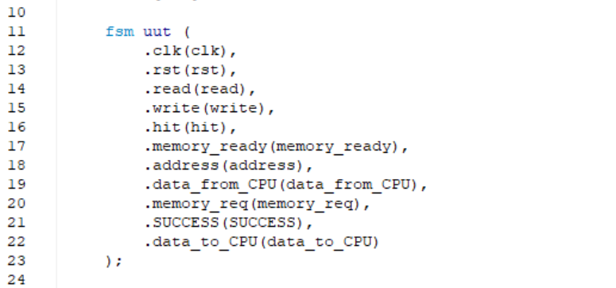
The testbench sends input signals to the FSM and observes its output signals. In this way, the behavior of the cache controller can be verified in multiple situations.

2. Input and Output Signals
The testbench defines several input signals using the reg type because their values are controlled inside the simulation.
The input signals are:
- clk – clock signal used to synchronize the FSM
- rst – reset signal used to initialize the FSM
- read – indicates a read request from the CPU
- write – indicates a write request from the CPU
- hit – indicates whether the requested address is found in cache
- memory_ready – indicates that the main memory has completed the requested operation
- address – 32-bit address sent by the CPU
- data_from_CPU – 32-bit data sent by the CPU during a write operation
The output signals are declared as wire because they are generated by the tested FSM module.
The output signals are:
SUCCESS – indicates that the requested operation has been completed successfully
- data_to_CPU – data returned to the CPU during a read operation
- memory_req – request signal sent by the cache controller to the main memory
- st – internal state of the FSM, used only for waveform visualization

3. Clock Generation
The clock signal is generated using an always block:
always #10 clk = ~clk;
This instruction toggles the value of clk every 10 time units. As a result, the clock period is 20 time units.The clock is important because the FSM changes its state on the positive edge of the clock signal.

4. Accessing Internal Signals for Waveform Visualization
The testbench also accesses some internal signals of the fsm module in order to make the simulation easier to analyze.
This assignment allows the internal state of the FSM to be displayed in the waveform.
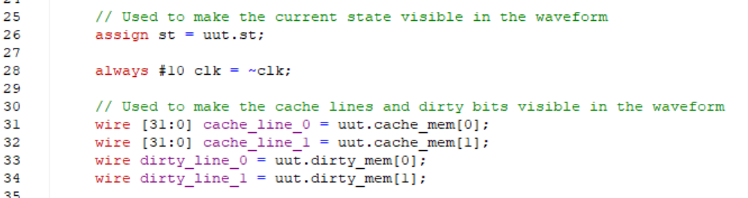
The testbench also monitors the cache lines and dirty bits.
These signals are useful because they show the content of each cache line and whether a line has been modified. The dirty bit is important because it determines whether a write-back operation is necessary before replacing a cache line.

5. State Display Task
The print_state task is used to display the current state of the FSM in a readable format.
Instead of displaying only the binary value of the state, the task converts each state code into a meaningful name, such as IDLE, COMPARE, READ_HIT, READ_MISS, WRITE_HIT, WRITE_MISS, WRITE_BACK, EVICT, or ALLOCATE.
This makes the simulation output easier to understand and helps verify that the FSM follows the expected sequence of states.
The task also displays the current dirty bit and the SUCCESS signal:
$write("(dirty=%b, success=%b) ", uut.dirty_mem[uut.idx], SUCCESS);
This information is useful for debugging, especially in cases where the cache line must be written back to memory before being replaced.

6. The run_fsm Task
The run_fsm task is the main testing task used in this testbench. It receives the operation parameters as inputs:
- read request
- write request
- hit or miss value
- address
- data sent by the CPU
This task applies the input values to the FSM and then waits until the FSM returns to the IDLE state.
During the simulation, if the FSM sends a memory request using the memory_req signal, the testbench simulates the response of the main memory by activating memory_ready.
This behavior models the communication between the cache controller and the main memory.
For read operations, the task also captures the value returned by the FSM through data_to_CPU.
At the end of each test, a debug message is displayed in the console, showing whether a read or write operation was performed and what data was used.

7. Reset Sequence
At the beginning of the simulation, all input signals are initialized to zero.
Then, the reset signal is activated:
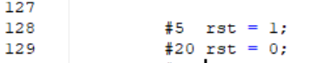
The reset signal initializes the FSM and places it in a known starting state. This ensures that the simulation begins from a predictable condition.

8. Test Scenarios
The testbench contains seven test cases designed to verify the main situations that can appear in a cache controller.
Test 1 – Read with Cache Hit
run_fsm(1, 0, 1, 32'h00002000, 32'h0);
This test simulates a read operation where the requested data is already present in the cache. The expected behavior is that the FSM performs a read hit and returns the data to the CPU without requesting access to main memory.
Test 2 – Read with Cache Miss
run_fsm(1, 0, 0, 32'h00002000, 32'h0);
This test simulates a read operation where the data is not found in the cache. The FSM must request data from main memory and then allocate it in the cache.
Test 3 – Write with Cache Hit
run_fsm(0, 1, 1, 32'h00002004, 32'hDEADBEEF);
This test verifies a write operation where the address is already present in the cache. The data is written directly into the cache line, and the dirty bit is set.
Test 4 – Write with Cache Miss and Dirty Line
run_fsm(0, 1, 0, 32'hFFFF0004, 32'hCAFEAFFE);
This test verifies a write miss case where the selected cache line is dirty. Since the cache line contains modified data, the FSM must first perform a write-back operation before replacing it with new data.
Test 5 – Read Hit After Write Miss
run_fsm(1, 0, 1, 32'hFFFF0004, 32'h0);
This test checks whether the value written in the previous test was correctly stored in the cache. The expected behavior is a read hit.
Test 6 – Write Miss with Clean Line
run_fsm(0, 1, 0, 32'h00005000, 32'h12345678);
This test verifies a write miss when the selected cache line is clean. In this case, no write-back operation is necessary, because the old data was not modified.
Test 7 – Read Hit from Line 0
run_fsm(1, 0, 1, 32'h00005000, 32'h0);
This final test verifies that the data written in the previous operation can be read successfully from cache.

9. Waveform Generation
The following instructions are used to generate a waveform file:
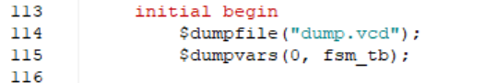
The waveform helps analyze the timing of the signals, the state transitions, the cache content, and the dirty bits.
The fsm_tb testbench verifies the main functionalities of the cache controller FSM. It tests read and write operations, cache hits, cache misses, dirty line replacement, write-back operations, and memory allocation.
The use of tasks makes the testbench easier to read and avoids repeating the same simulation code for each test case. The displayed messages and waveform signals help observe the internal behavior of the FSM and confirm that the cache controller works as expected.

